**7.7 Angle of Depression and Angle of Elevation Stations**

*You must draw a picture & show your work to receive full credit*

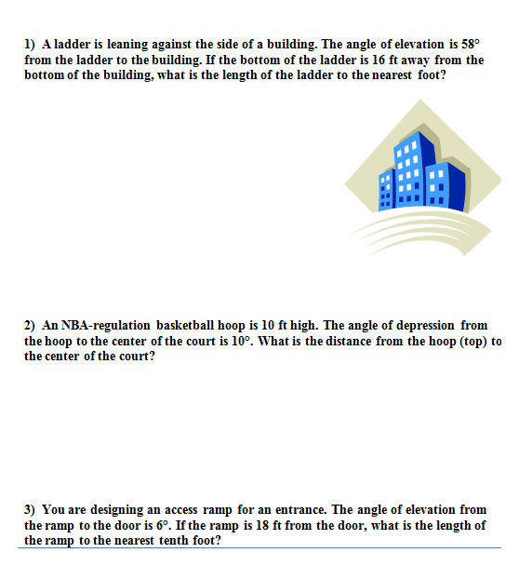



1)

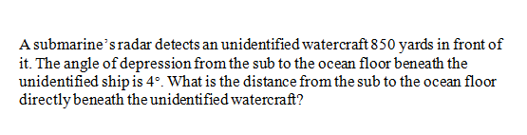

4)

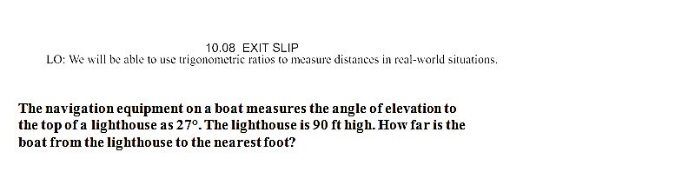

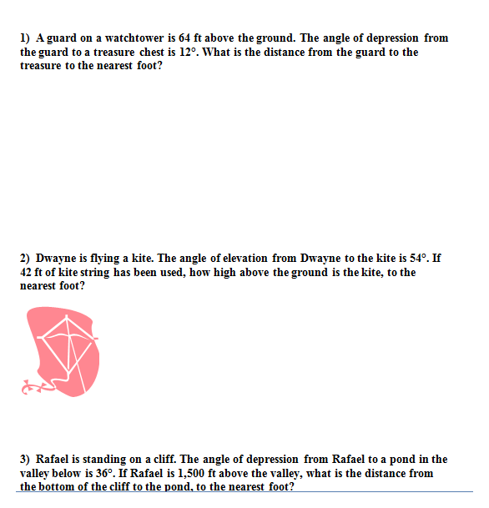





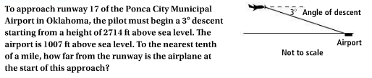

Screen%20Shot%202017-02-02%20at%2011.06.09%20PM.png

Screen%20Shot%202017-02-02%20at%2011.06.27%20PM.png

